**Natural Disasters Intensity Analysis and Classification using Artificial Intelligence**

**ABSTRACT** :

Natural disasters not only disturb the human ecological system but also destroy the properties and critical infrastructures of human societies and even lead to permanent change in the ecosystem. Disaster can be caused by naturally occurring events such as earthquakes, cyclones, floods, and wildfires. Many deep learning techniques have been applied by various researchers to detect and classify natural disasters to overcome losses in ecosystems, but detection of natural disasters still faces issues due to the complex and imbalanced structures of images. To tackle this problem, we developed a multilayered deep convolutional neural network model. The proposed model works in two blocks: block-i convolutional neural network (b-i cnn), for detection and occurrence of disasters, and block-ii convolutional neural network (b-ii cnn), for classification of natural disaster intensity types with different filters and parameters. The model is tested on 4428 natural images and performance is calculated and expressed as different statistical values: sensitivity (se), 97.54%; specificity (sp), 98.22%; accuracy rate (ar), 99.92%; precision (pre), 97.79%; and f1-score (f1), 97.97%. The overall accuracy for the whole model is 99.92%, which is competitive and comparable with state-oftheart algorithms.

**PROJECT DESCRIPTION :**

Natural disasters not only disturb the human ecological system but also destroy the properties and critical infrastructures of human societies and even lead to permanent change in the ecosystem. Disaster can be caused by naturally occurring events such as earthquakes, cyclones, floods, and wildfires. Many deep learning techniques have been applied by various researchers to detect and classify natural disasters to overcome losses in ecosystems, but detection of natural disasters still faces issues due to the complex and imbalanced structures of images. To tackle this problem, we developed a multilayered deep convolutional neural network model that classifies the natural disaster and tells the intensity of disaster of natural The model uses an integrated webcam to capture the video frame and the video frame is compared with the Pre-trained model and the type of disaster is identified and showcased on the OpenCV window.

**TECHNOLOGIES USED :**

Python, CNN, IBM Cloud, IBM Watson Studio,IBM Cloudant DB, Deep Learning, PythonFlask.

**PROJECT ARCHITECTURE :**

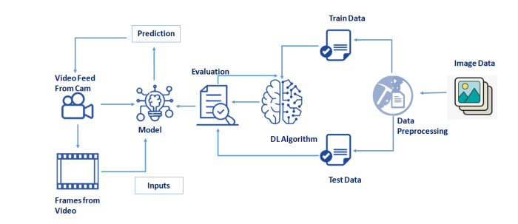

**METHODOLOGY :**

This section defines the overall method for natural disaster intensity analysis and classification based on multispectral images using a multilayered deep convolutional neural network. Moreover, this method consists of two blocks of a convolutional neural network. The first block detects a natural disaster occurring and the second one defines the intensity type of the natural disaster. Additionally, the first block consists of three miniconvolutional blocks with four layers each, including an image input and fully connected layers. On the other hand, the second block also consists of three miniconvolutional blocks with two layers each and includes an image input layer and fully connected layer.

**CONCLUSION :**

The proposed multilayered deep convolutional neural network was simulated on the computer system with Core i7, Central Processing Unit (CPU) 2.8 Ghz with 16 GB RAM in MATLAB 2018a and different types of results were calculated.

**REFERENCES :**

* Becker, G. 1976. “Altruism, Egoism and Genetic Fitness: Economics and Sociobiol- -ogy,” Journal of Economic Literature, 14, pp. 817-826.
* Bellows, J. and E. Miguel. 2009. “War and Local Collective Action in Sierra Leone,” Journal of Public Economics, 93(11-12), pp. 1144-57.
* Berg, J., J. Dickhaut, and K. McCabe. 1995. “Trust, Reciprocity, and Social History,” Games and Economic Behavior, 10, pp. 122-142.
* Boyd, R., H. Gintis, S. Bowles, and P. Richerson. 2002. “The evolution of altruistic punishment,” Proceedings of the National Academy of Sciences, 100, pp. 3531–3535

**SUBMITTED BY:**

**Team ID :** PNT2022TMID45665

**Team Size :** 4

**Team Leader :** PRAVEEN KUMAR C

**Team member :** KARTHIKEYAN S

**Team member :** MAHAMALINI E

**Team member :** BALAJI P